2.21

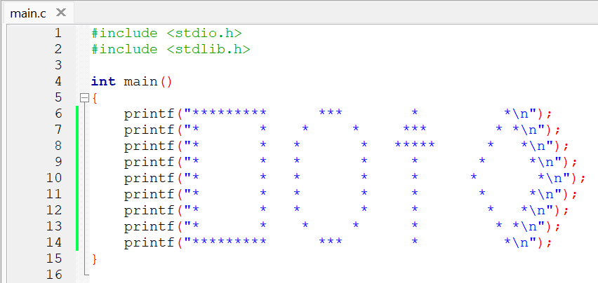

2.23

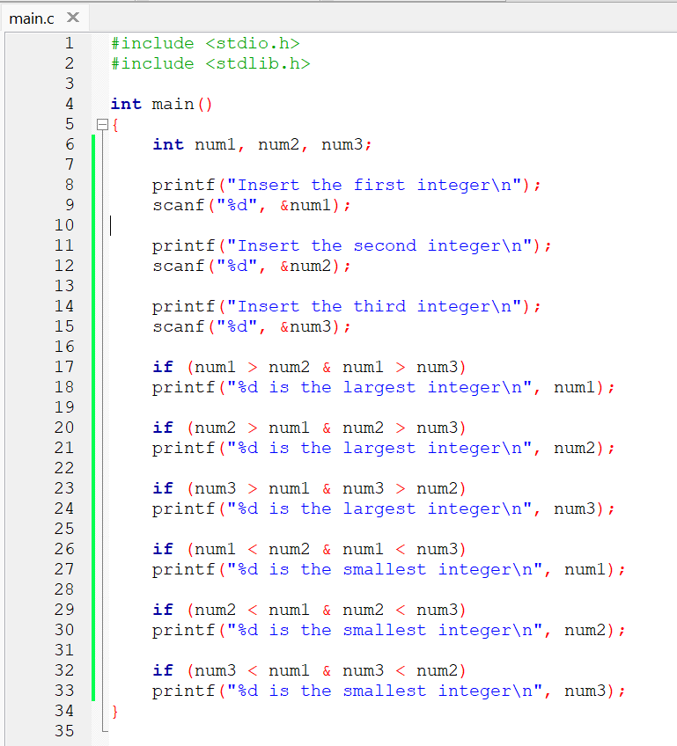

2.24

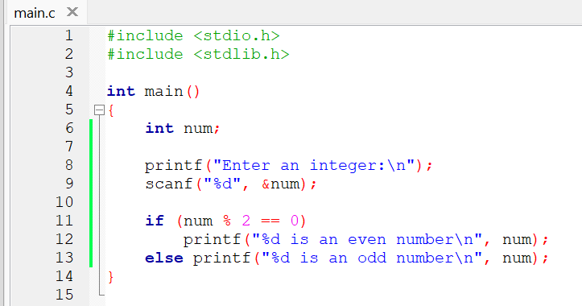

2.25

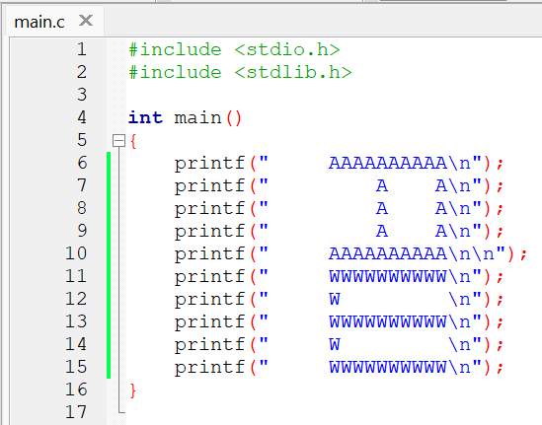

2.26

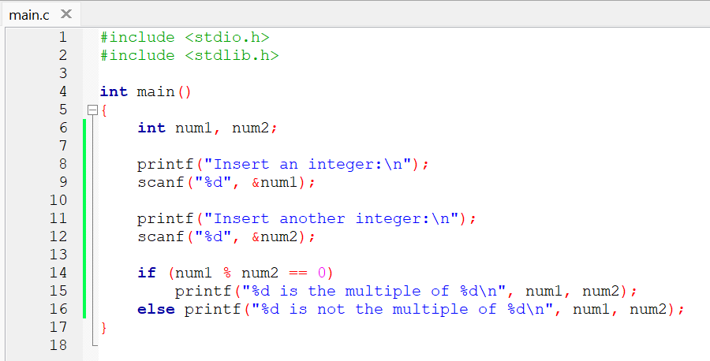

2.27

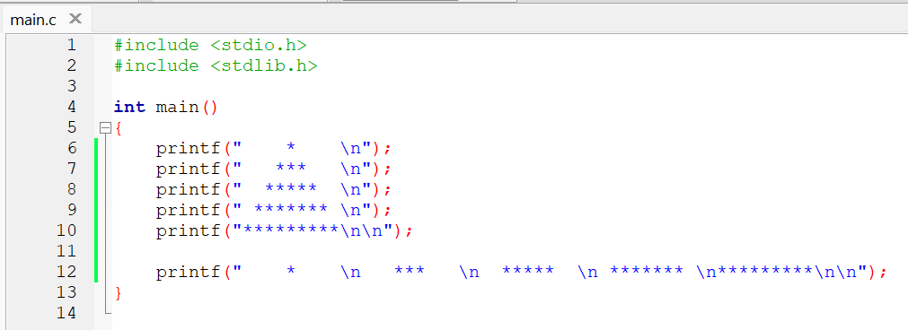

2.31

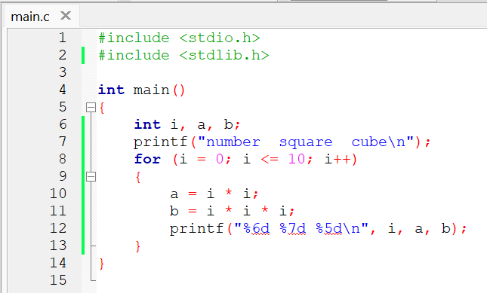

2.32

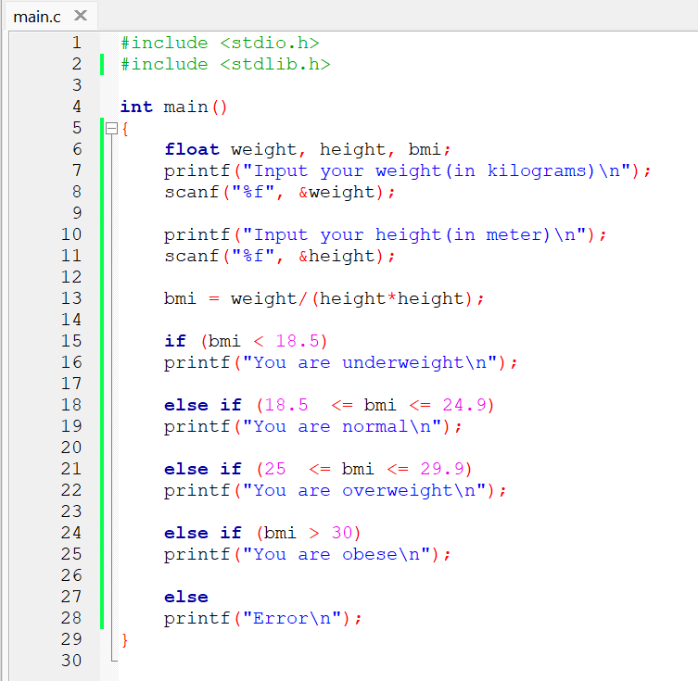

2.33

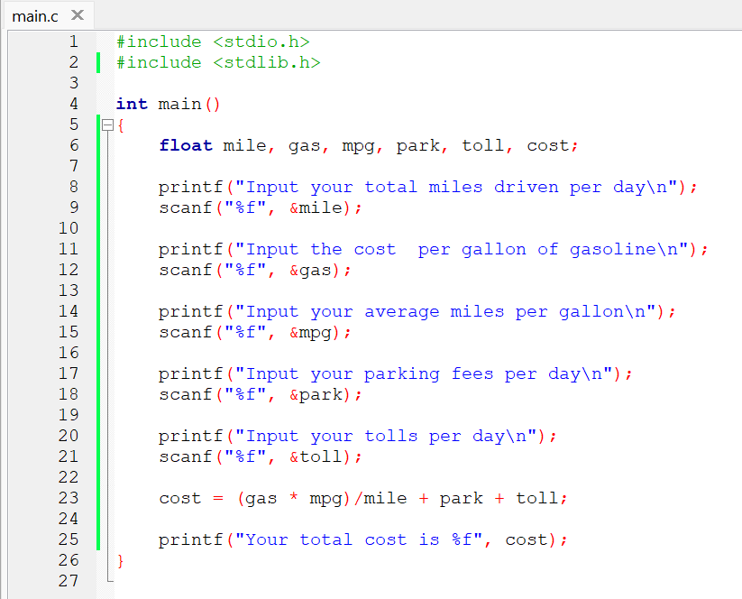

Conclusion:

From doing this homework, I learnt about the workings of the “printf” and “scanf” library function. I also learnt to use operators in C. Other than that, I also learnt how to use “if” and “else” statement. Last but not least, to assign strings to data types (int, char, string, float, double, long, etc.) including their format specifier.

Code : https://github.com/AldrichWijaya/Homework